Random and Random Order Controller

Random Controller : loop count = 3

pre-condition -login -> test3 -> postcondition - login

pre-condition -login -> test1 -> postcondition - login

pre-condition -login -> test2 -> postcondition - login

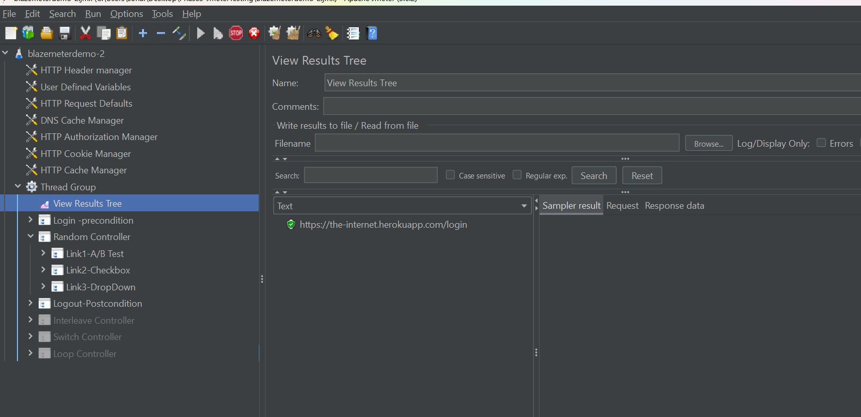

Random order controller:

pre-condition -login -> test3, tes1, test2 -> postcondition - login

pre-condition -login -> test1, tes3, test2 -> postcondition - login

pre-condition -login -> test3, tes2, test1 -> postcondition - login

